

SECP1513

TECHNOLOGY AND INFORMATION SYSTEM

DESIGN THINKING:

META WORKFORCE (GROUP 8)

LECTURER:

DR. MUHAMMAD IQBAL TARIQ BIN IDRIS

SUBMITTED BY:

ABHILASHINIE A/P PRABAHARAN(A23CS0031)

VIBHUSHA A/P SAMPASIVA RAO(A23CS0194)

BEATRICE ANN DAVID(A23CS0055)

ONG JIN YIE(A23CS0169)

AMR YOUSEF ALWAFI(A23CS4005)

ALNADHARI MUSTAFA SAEED ABDULQADER(A20EC4071)

SEMESTER 1(2023/2024)

**TABLE OF CONTENTS**

| Number | Content | Page |
| --- | --- | --- |
| 1 | Introduction | 1 |
| 2 | Problem Background | 1 |
| 3 | Empathy | 1-3 |
| 4 | Define | 3 |
| 5 | Problem Idea/Solution | 4 |
| 6 | Ideate | 4 |
| 7 | Prototype |  |
| 8 | Test Mode |  |
| 9 | Reflection |  |
| 10 | Task Assignment |  |
| 11 | References |  |

**Introduction**

Design Thinking is an iterative process in which we seek to understand the user, challenge assumptions, and redefine problems in an attempt to identify alternative strategies and solutions that might not be instantly apparent with our initial level of understanding.(Dam, R. F & Siang, T. Y , 2021). Design thinking also differs from other innovation and ideation processes in that it is solution-based and user-centered rather than problem-based. This indicates that it focuses on solving the problem, not the problem itself.

The growth of online shopping has led to an increase in return cases, which can be difficult for both online sellers and buyers.To address this issue, we created a website where users can preview and review garments with immersive and interactive elements.This report describes how design thinking was applied to the development of his website, including the stages of empathy, definition, ideation, prototyping, and testing.

**Problem Background**

Current e-commerce systems lack interactive and immersive elements, which can result in a suboptimal shopping experience and high return rates. To solve this challenge, we propose the development of an augmented reality (AR) website for online shopping, where customers can preview products in their own environment through the website.The solution aims to bridge the gap in the shopping experience by allowing users to visualize products in their personal space, ultimately facilitating informed purchasing decisions. By applying design thinking, a human-centered, solution-based problem-solving approach, AR applications are developed with a deep understanding of users' needs and preferences, improving the overall online shopping experience.

**Empathy**

For the first part of empathy, we made a google form on User Experience on Clothing Shopping Platforms Survey. This google form is designed to gain inputs from customers that are using clothing shopping platforms such as Shopee and Lazada about their current satisfaction using these websites. Not only that, this google form is made to gain inputs from the customers regarding their knowledge or exposure to Augmented Reality (AR) technology. In the google form, there are two sections that need to be filled up. The first section is known as Section A which focuses on Personal Information that comprises of gender, age and race. This section is vital to know about the customers’ background and how it influences their decisions later in Section B.

As for Section B, the second section in the google form. This section comprises of 8 required to fill up questions that focuses on the issue of user experience on clothing shopping platforms.

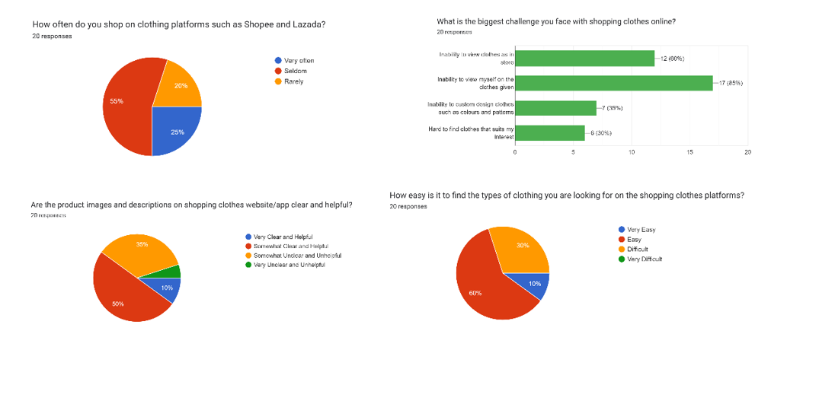

Diagram 2 shows four out of eight questions that have been asked in the google form. The first question is ‘How often do you shop on clothing platforms such as Shopee and Lazada?’. Around 55% responded seldom and 20% responded rarely. The second question is ‘What is the biggest challenge you face with shopping clothes online?’. Around 85% responded inability to view myself on the clothes given and 30% responded hard to find clothes that suits my interest. The third question is ‘Are the product images and descriptions on shopping clothes website/app clear and helpful?’. Around 50% responded somewhat clear and helpful while 10% responded very clear and helpful. Next, ‘How easy is it to find the types of clothing you are looking for on the shopping clothes platforms?’ is the fourth question. Around 60% responded easy and only 10% responded very easy.

Furthermore, ‘How satisfied are you with your shopping experience on shopping clothes platform?’ is the fifth question which 80% responded satisfied followed by the sixth question which is ‘How familiar are you with Augmented Reality (AR) technology?’ that made 50% responded familiar. The seventh question is ‘Do you prefer online shopping with AR integration? (e.g., Ikea Furniture App, Sephora Makeup App)?’ which gets 80% responded to yes. Lastly, the eighth question is ‘Does a product that can be previewed in an AR

environment help you to decide whether to purchase or not?’ that gets 75% of respondents to vote yes.

As for the second part of empathy, we have managed to interview an online business owner who sells Muslimah-friendly clothes via Shopee and TikTok. The summary of the interview is as follows. The owner who runs sy ciciComel company has been in business for about four years. Apparently, the owner had faced many hurdles in doing business such as marketing issue, return clothes cases due to incorrect size or colour. The interviewee further talked about the consequences of these challenges which is reducing her profit gain. As a result. the interviewee did come up with solutions like keeping up with clothing trends and put up a measurement size chart in her account to avoid the return clothes issues. This further gives Vibhusha and Abhilashinie, the interviewers a chance to introduce to the interviewee about the technology of Augmented Reality (AR) and further explaining it on how this technology can solve the hurdles that the interviewee is currently facing. Not only that, they gave an example on how AR works by taking the IKEA example that further illustrates the uses of AR clearly. For example, IKEA uses AR to allow customers to view their interest furniture in their own rooms. This idea delights the interviewee, and she agrees with the benefits of AR technology saying that by implementing this technology in her business, her problems could be minimised.

**Define:**

Problem Statement:

The existing e-commerce model, typified by platforms like Shopee, faces a significant drawback in that customers are unable to interact with products or visualize them in their personal spaces. This limitation contributes to unmet expectations and potentially higher return rates, undermining the overall satisfaction of the customer.

**Proposed Idea/Solutions:**

The proposed solution involves the development of an Augmented Reality application that leverages smartphone technology to allow customers to preview products in their real-world environments. This application introduces a new dimension to online shopping by enabling users to visualize products in their own spaces, enhancing their ability to make informed purchasing decisions.

**Ideate**

First, we used Google Meet for our first meeting to talk about our project and come up with a great idea. The Shopee app will now have an AR preview feature, as we have decided. Using Google Meet, our team members Abhilashinie and Vibhusha conducted an interview with the owner of the Sy CiciComel company who does business in Shopee and Tik Tok. Additionally, we used a Google Form survey to collect customer feedback from the students. Our goal is to lower the number of clothing returns. We therefore concentrated on the augmented reality preview function, which allows users to see clothing on themselves. We wrote a handwritten prototype so that you could see our project up close. For user convenience, we offer both front and back camera views.

**Prototype**

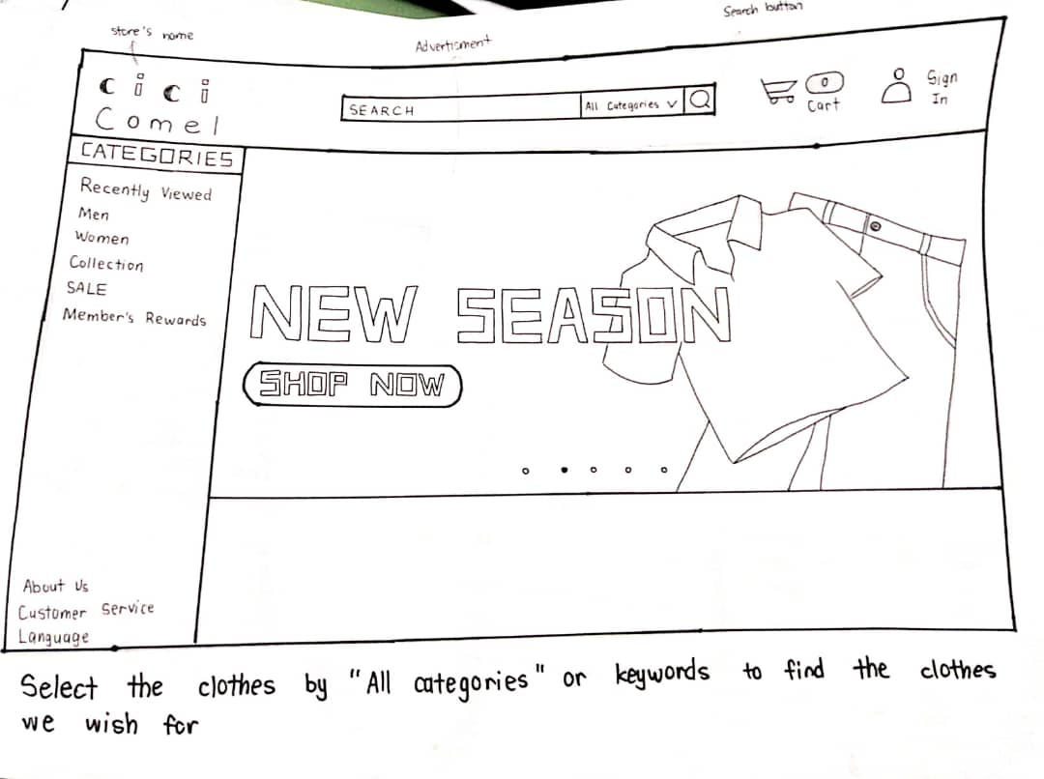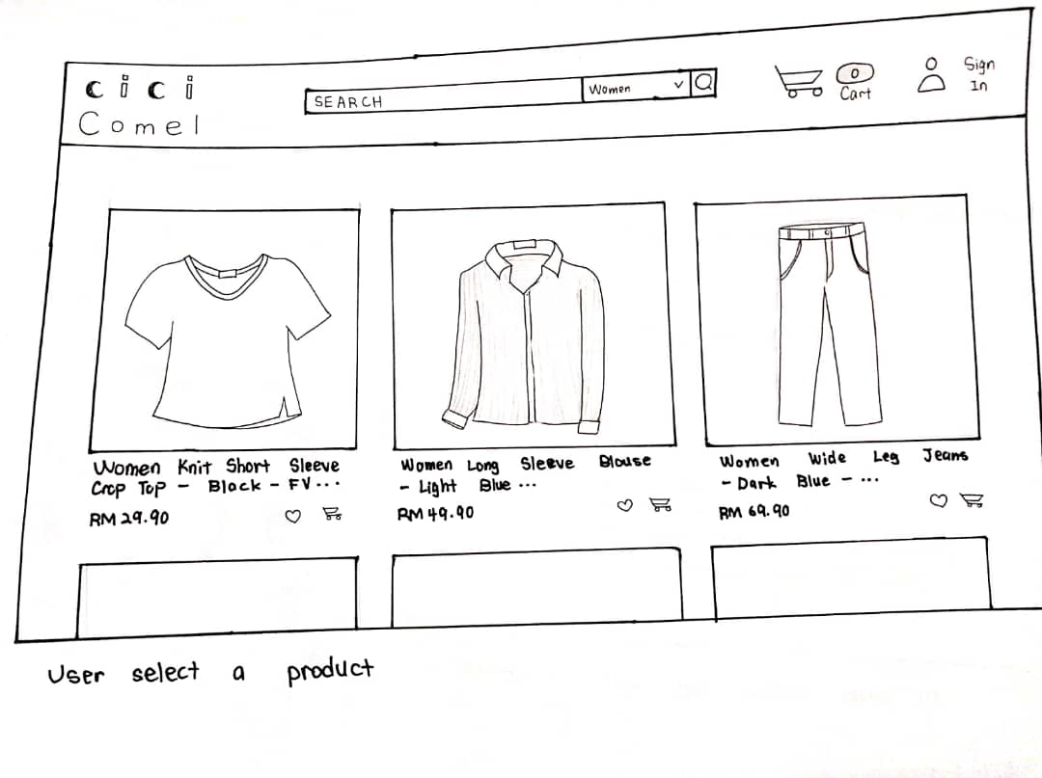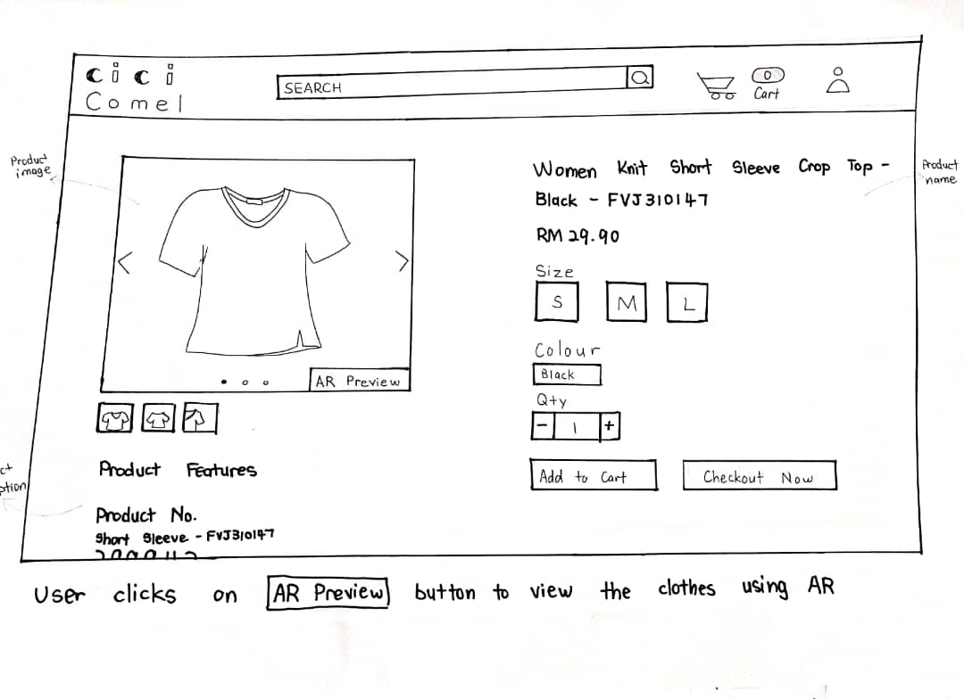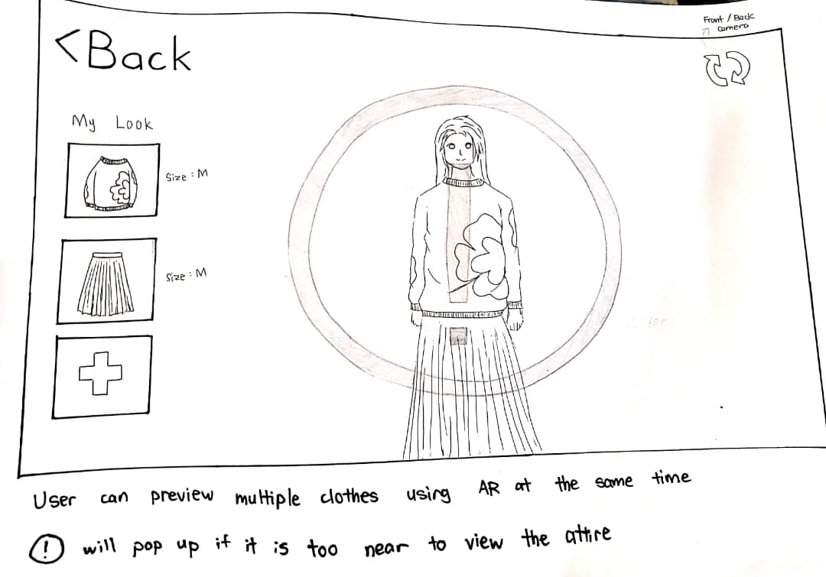

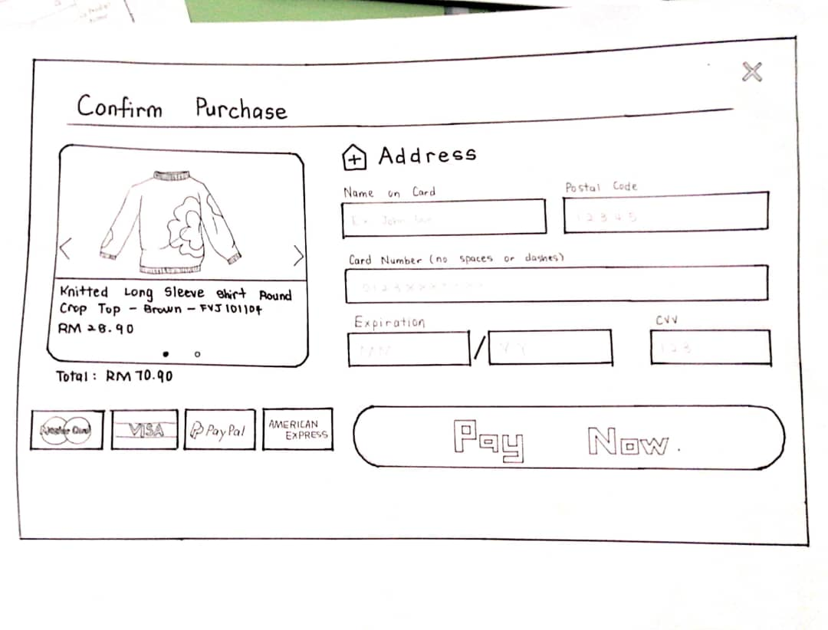

**Test Mode**

A Google Form was created with images of the prototype and a list of questions consisting of 12 questions for its users. The first 10 questions were based on the System Usability Scale (SUS) questionnaire and the 2 questions were about overall experience.  
These are the questions that were asked:  
A) SUS Questions:

1. *I think that I would like to use this AR clothing selection feature frequently.*
2. *I found the process of selecting clothes and using the AR feature unnecessarily complex.*
3. *I thought the clothing selection and AR preview system was easy to use.*
4. *I think that I would need the support of a technical person to be able to use the AR feature.*
5. *I found the various functions in this clothing store (search, selection, AR preview, checkout) were well integrated.*
6. *I thought there was too much inconsistency in the way the clothing store operates.*
7. *I would imagine that most people would learn to use this online clothing store with AR technology very quickly.*
8. *I found the system very cumbersome to navigate and select clothes.*
9. *I felt very confident using the clothing store's website and its AR features.*
10. *I needed to learn a lot of things before I could get going with selecting clothes and using the AR technology on this website.*

B) Overall Experience Questions:

1. *Do you recommend this website for production?*
2. *Given your experience, how likely are you to recommend this AR-integrated clothing store to a friend or colleague?*

Prototype testing yielded highly positive results, with participants expressing strong agreement on various aspects of our AR-integrated clothing store. Users found the AR clothing selection feature easy to use and expressed a desire to use it frequently. They also felt confident using the AR features and believed that most people would quickly adapt to the platform. The system's functions, including search, selection, AR preview, and checkout, were perceived as well-integrated, while concerns about complexity, inconsistency, and the need for technical support were minimal. Importantly, all participants recommended the website for production, underlining the overall satisfaction and success of our prototype in delivering an intuitive and user-friendly AR shopping experience.

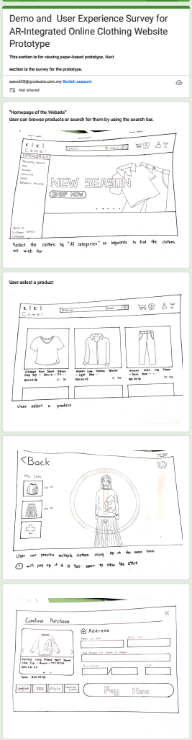



**Note**:

For SUS questions, the answers were represented by numbers from 1 to 5, where:

Strongly Disagree is represented by 1.

Disagree is represented by 2.

Neutral is represented by 3.

Agree is represented by 4.

Strongly Agree is represented by 5.

**Link of the Google Form:**

<https://docs.google.com/forms/d/e/1FAIpQLSf0k5QZU3cyGlzRHNECXV2tPM-Lx4j4h0hBKQR-aOyqdQcZaA/viewform?usp=sharing>

**Result of the questionnaire:**

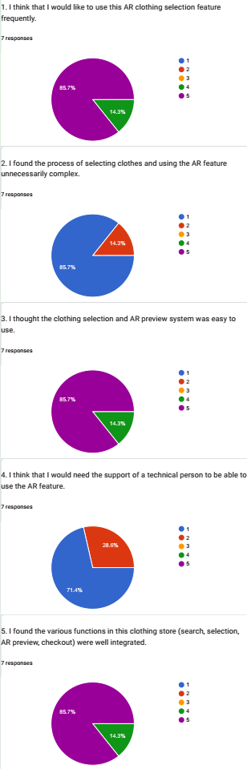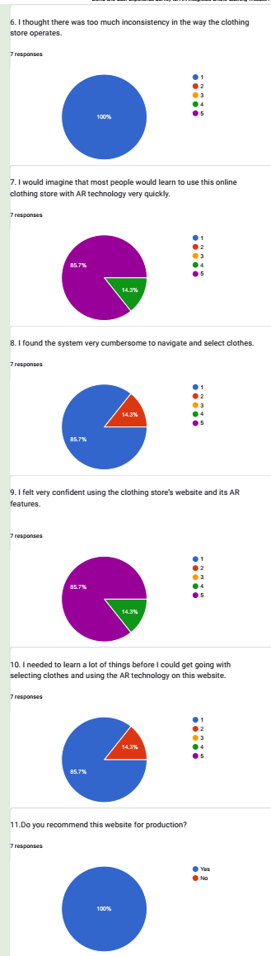

**Reflection**

**Abhilashinie A/P Prabaharan**

My goal is to achieve success in the field of information technology. This project has taught me a great deal. I had the incredible opportunity to dive into various phases of project development throughout the project. From here, I learned how to create a project and how to successfully complete it. Furthermore, this project provided me with an opportunity to hone my skills in areas such as leadership, communication, and so on. In the future, I will incorporate the lessons I have learned throughout the project.

**AMR YOUSEF ALWAFI**I am aiming to do well in information technology, and this project has been a great learning experience for me. I learned how to start a project and make sure it gets done. It gave me the chance to understand how a project goes from start to finish. Also, it helped me get better at communicating with others. In the future, I'm going to use what I learned in whatever I do next.

**Vibhusha A/P Sampasiva Rao**  
 The design thinking project I worked on consisted of five phases, and I learned how to approach problems by proposing solutions and creating prototypes of products, applications, or websites. As a computer science student, I believe it is essential to master this methodology. Additionally, I was responsible for interviewing our client and learned how to professionally interview clients and understand their problems and expectations. Overall, this project helped me understand the importance of a human-centered approach to problem solving and how design thinking can be used to develop innovative solutions.

**Alnadhari Mustafa Saeed Abdulqader**

This course and project have been a valuable learning experience. Through project management, I've honed my teamwork and communication skills. In a design thinking project, I explored creative problem-solving and human-centered approaches. These experiences have equipped me to tackle future challenges with technical expertise and innovative thinking.

**Beatrice Ann David**

All thanks to my teammates that we managed to finish our prototype in time, with Jing Yie, one of my teammates amazing drawing skills and Mustafa's ideas and also the others, we've managed to draw a perfect prototype and interview a bussinesswoman. While Mustafa and I were collecting datas from people around us that are using online clothing platforms via google form. It was a fun and challenging experience overall.

**Task Assignment**

Each group member had a specific task to do in order to finish the report. The task of finishing the introduction and problem background was assigned to Vibhusha. The Empathy phase was given to Beatrice to complete. Aside from that, Amr's assignment was to complete the Define phase. Additionally, Mustafa was given the task of doing the test phase and Abhilashinie the ideate phase. Jin Yie worked on our handwritten prototype.

**References**

1)Kim, J. H., Kim, M., Park, M., & Yoo, J. (2023, January 7). Immersive interactive technologies and virtual shopping experiences: Differences in consumer perceptions between augmented reality (AR) and virtual reality (VR),. *Volume 77*.<https://doi.org/10.1016/j.tele.2022.101936.>

2)Makarov, A. (2023, December 22). *How to Build Augmented Reality Virtual Try-On Solutions for eCommerce*. MobiDev. Retrieved January 20, 2024,

from <https://mobidev.biz/blog/augmented-reality-virtual-try-on-technology-for-ecommerce>

3)Interaction Design Foundation, Dam, R. F., & Siang, T. Y. (2021). What is design thinking and why is it so popular?.